Appendix

Calculating Land Residual
Fig A 1 Size Factor Estimation by Power Model
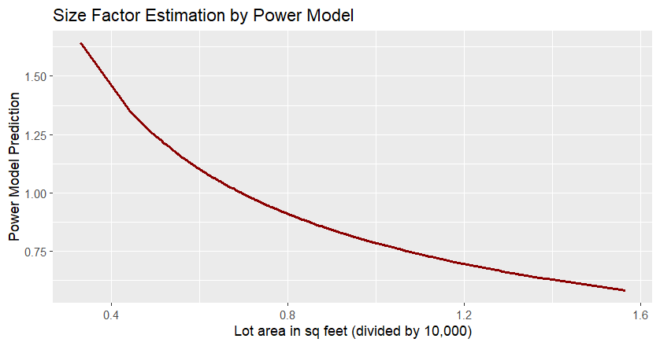

Unit Valuation Method
Fig A 2. Land Residual Ratio after Adjustment for Land Features and Neighborhood
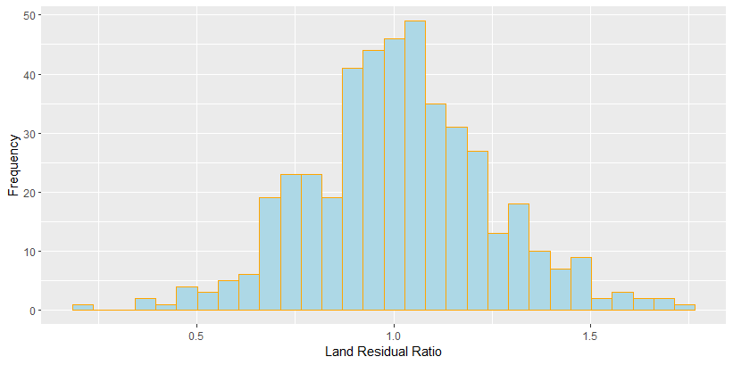

Table A 1 Mann-Whitney Results - general land value adjusted for culdesac
Mann-Whitney Results - general land value adjusted for culdesac
Variable | Value | Number | Mean Rank | Ays. Significance
corner | 0 | 378 | 219 | 0.12
 | 1 | 68 | 246
culdesac | 0 | 417 | 225 | 0.48
 | 1 | 29 | 207
alley | 0 | 301 | 247 | 0.00
 | 1 | 145 | 175
wooded | 0 | 410 | 225 | 0.35
 | 1 | 36 | 204
pie_shpe | 0 | 420 | 221 | 0.12
 | 1 | 26 | 261
slope | 0 | 389 | 225 | 0.53
 | 1 | 57 | 213
abv_road | 0 | 367 | 228 | 0.12
 | 1 | 79 | 203

Table A 2 Mann-Whitney Results - general land value adjusted for culdesac and alley
Mann-Whitney Results - general land value adjusted for culdesac and alley
Variable | Value | Number | Mean Rank | Ays. Significance
corner | 0 | 378 | 220 | 0.19
 | 1 | 68 | 242
culdesac | 0 | 417 | 227 | 0.06
 | 1 | 29 | 179
alley | 0 | 301 | 221 | 0.60
 | 1 | 145 | 228
wooded | 0 | 410 | 226 | 0.11
 | 1 | 36 | 191
pie_shpe | 0 | 420 | 223 | 0.67
 | 1 | 26 | 234
slope | 0 | 389 | 226 | 0.37
 | 1 | 57 | 209
abv_road | 0 | 367 | 229 | 0.04
 | 1 | 79 | 197

Table A 3 Mann-Whitney Results - general land value adjusted for culdesac, alley, and abv_road
Mann-Whitney Results - general land value adjusted for culdesac, alley, and abv_road
Variable | Value | Number | Mean Rank | Ays. Significance
corner | 0 | 378 | 221 | 0.29
 | 1 | 68 | 239
culdesac | 0 | 417 | 225 | 0.41
 | 1 | 29 | 205
alley | 0 | 301 | 223 | 0.84
 | 1 | 145 | 225
wooded | 0 | 410 | 227 | 0.09
 | 1 | 36 | 189
pie_shpe | 0 | 420 | 222 | 0.47
 | 1 | 26 | 241
slope | 0 | 389 | 223 | 070
 | 1 | 57 | 230
abv_road | 0 | 367 | 224 | 0.87
 | 1 | 79 | 222

Market-based Depreciation Factor
Fig A 3. Depreciation Factor versus Effective Age
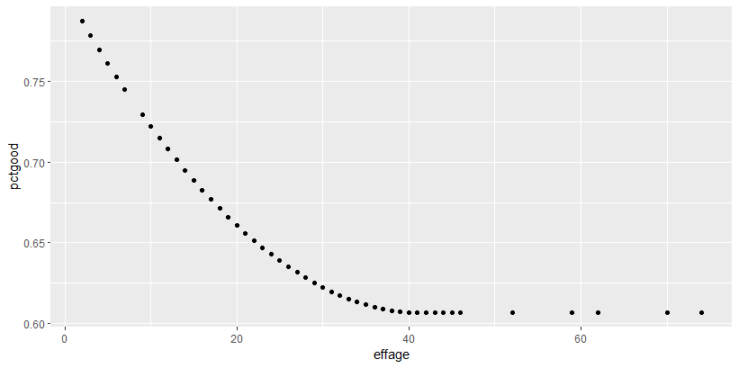

Testing Building Characteristics
Table A 4. Ratio Statistics for Mkfact1 adjusted for Split Level (Mkfactor2)
Split-level | Median | Lower Bound | Upper Bound | Actual Coverage | Minimum | Maximum | COD
0 | 1.00 | 0.98 | 1.02 | 95.54 | 0.41 | 1.79 | 13.82
1 | 1.00 | 0.89 | 1.08 | 95.90 | 0.61 | 1.21 | 12.53

Table A 5. Ratio Statistics for Mkfact3 (adjusted by Split-level and Garage Type) based on Bedrooms
Garage Type | Median | Lower Bound | Upper Bound | Actual Coverage | Minimum | Maximum | COD
2 | 0.95 | 0.91 | 0.98 | 94.51 | 0.55 | 1.78 | 14.22
3 | 1.02 | 1 | 1.04 | 95.05 | 0.41 | 1.55 | 12.27
4 | 0.93 | 0.85 | 1.02 | 92.16 | 0.62 | 1.53 | 19.03
2 | 0.95 | 0.91 | 0.98 | 94.51 | 0.55 | 1.78 | 14.22

Table A 6. Ratio Statistics for Mkfact4 (adjusted by Split-level, Garage Type, and Bedrooms) based on Carport
Garage Type | Median | Lower Bound | Upper Bound | Actual Coverage | Minimum | Maximum | COD
2 | 0.95 | 0.91 | 0.98 | 94.51 | 0.55 | 1.78 | 14.22
3 | 1.02 | 1 | 1.04 | 95.05 | 0.41 | 1.55 | 12.27
4 | 0.93 | 0.85 | 1.02 | 92.16 | 0.62 | 1.53 | 19.03
2 | 0.95 | 0.91 | 0.98 | 94.51 | 0.55 | 1.78 | 14.22

Table A 7. Ratio Statistics for Mkfact5 (adjusted by Split-level, Garage Type, Bedrooms, and Carport) based on Family Room
Garage Type | Median | Lower Bound | Upper Bound | Actual Coverage | Minimum | Maximum | COD
0 | 0.95 | 0.93 | 0.98 | 94.33 | 0.39 | 1.85 | 15.16
1 | 1.03 | 1.01 | 1.05 | 95.09 | 0.6 | 1.63 | 11.59
2 | 1.01 | 0.97 | 1.05 | 93.61 | 0.71 | 1.19 | 8.15

